CITY COUNCIL PROCEEDINGS
September 16, 2025
The City Council of the City of David City, Nebraska, met in open public session at 6:30 p.m. to hold a public hearing for the purpose of hearing support, opposition, criticism, suggestions or observations of taxpayers relating to the proposed budget for fiscal year 2025-2026. The meeting was held in the meeting room of the City Office located at 490 “E” Street, David City, Nebraska. The Public had been advised of the meeting by posting in four public places (City Office, US Post Office, Butler County Courthouse and Hruska Public Library). The Mayor and members of the City Council acknowledged advance notice of the meeting by signing the Agenda which is a part of these minutes. The advance notice to the Public, Mayor, and Council members conveyed the availability of the agenda, which was kept continuously current in the office of the City Clerk and was available for public inspection on the City’s website. No new items were added to the agenda during the twenty-four hours immediately prior to the opening of the Council meeting.
Present for the meeting were: Mayor Jessica Miller, Council members Keith Marvin, Bruce Meysenburg, Kevin Woita, Jim Angell, Rick Holland, and City Administrator Alan Zavodny, City Administrator Intern Raiko Martinez and City Clerk Tami Comte. Council member Jeremy Abel was absent.

The meeting opened with the Pledge of Allegiance.

Mayor Jessica Miller informed the public of the “Open Meetings Act” posted on the west wall of the meeting room and asked those present to please silence their cell phones. He also reminded the public that if they speak tonight in front of the Council that they must state their name and address for the record.

Mayor Jessica Miller declared the public hearing open at 6:31 p.m.

City Administrator Intern Raiko Martinez read the following power point presentation for the budget hearing.

(This space left intentionally blank)

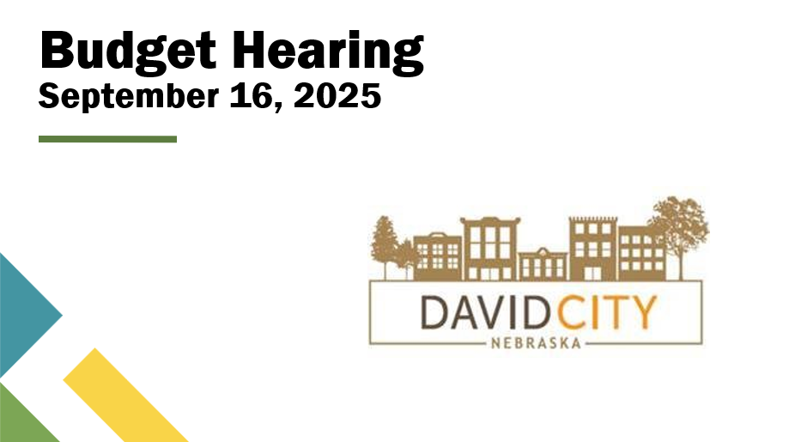

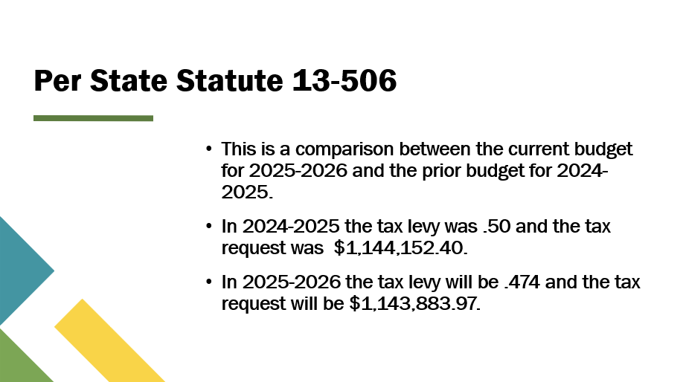
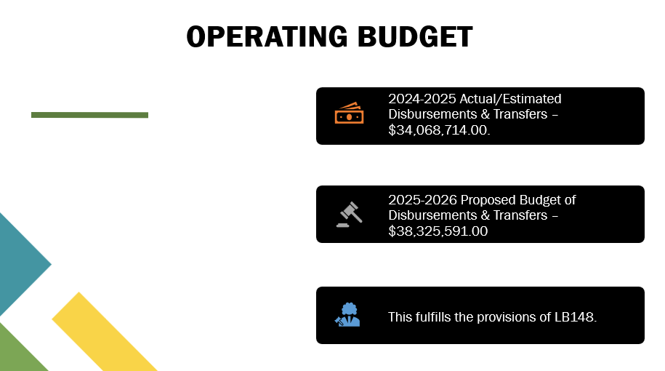



The presentation required by LB 148 was completed.

No citizens spoke at the public hearing.

Mayor Miller declared the public hearing closed at 6:32 p.m.

Council member Keith Marvin made a motion to adjourn. Council Member Jim Angell seconded the motion. The motion carried and Mayor Jessica Miller declared the meeting adjourned at 6:33 p.m.
Jeremy Abel: Absent, Jim Angell: Yea, Rick Holland: Yea, Keith Marvin: Yea, Bruce Meysenburg: Yea, Kevin Woita: Yea
Yea: 5, Nay: 0, Absent: 1

▲▲▲▲▲▲▲▲▲▲▲▲▲▲▲▲▲▲▲▲▲▲▲▲▲▲▲▲▲▲▲▲

CERTIFICATION OF MINUTES
September 16, 2025

I, Tami Comte, duly qualified and acting City Clerk for the City of David City, Nebraska, do hereby certify with regard to all proceedings of September 16, 2025; that all of the subjects included in the foregoing proceedings were contained in the agenda for the meeting, kept continually current and available for public inspection at the office of the City Clerk; that such subjects were contained in said agenda for at least twenty-four hours prior to said meeting; that the minutes of the meeting of the City Council of the City of David City, Nebraska, were in written form and available for public inspection within ten working days and prior to the next convened meeting of said body; that all news media requesting notification concerning meetings of said body were provided with advance notification of the time and place of said meeting and the subjects to be discussed at said meeting.

Tami Comte, City Clerk

